Brandon Dooley

Dooleyb1@tcd.ie

Date of Experiment: 2/12/2016

Lab Session: 14:00-16:00

*All circuit diagrams created using CircutDiagram*

*© 2016 Circuit Diagram*

Brandon Dooley ( #16327446 )

CS1025 Laboratory Experiment 3

CS1025 Laboratory Experiment 3

# Objective

* To investigate the effects that a capacitor has on a.c voltage.
* To investigate the effects different capacitances have on a.c voltage and capacitors.
* To investigate the effects different frequencies have on a.c voltage and capacitors.

# Method (Part One)

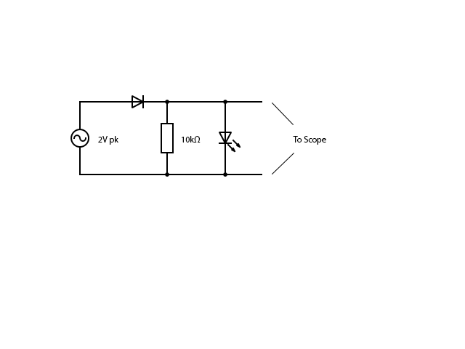 ***Fig 1.1***

1. The apparatus was set up as shown in *Fig 1.1*, with a 10kΩ resistor connected in parallel with an LED and the pair connected in series with a diode. The circuit was then attached to a 2V pk a.c power supply and current was allowed to flow through the circuit. Using an oscilloscope the input and output voltages were recorded, graphed and compared.

# Results (Part One)

**Input and Output Voltages**

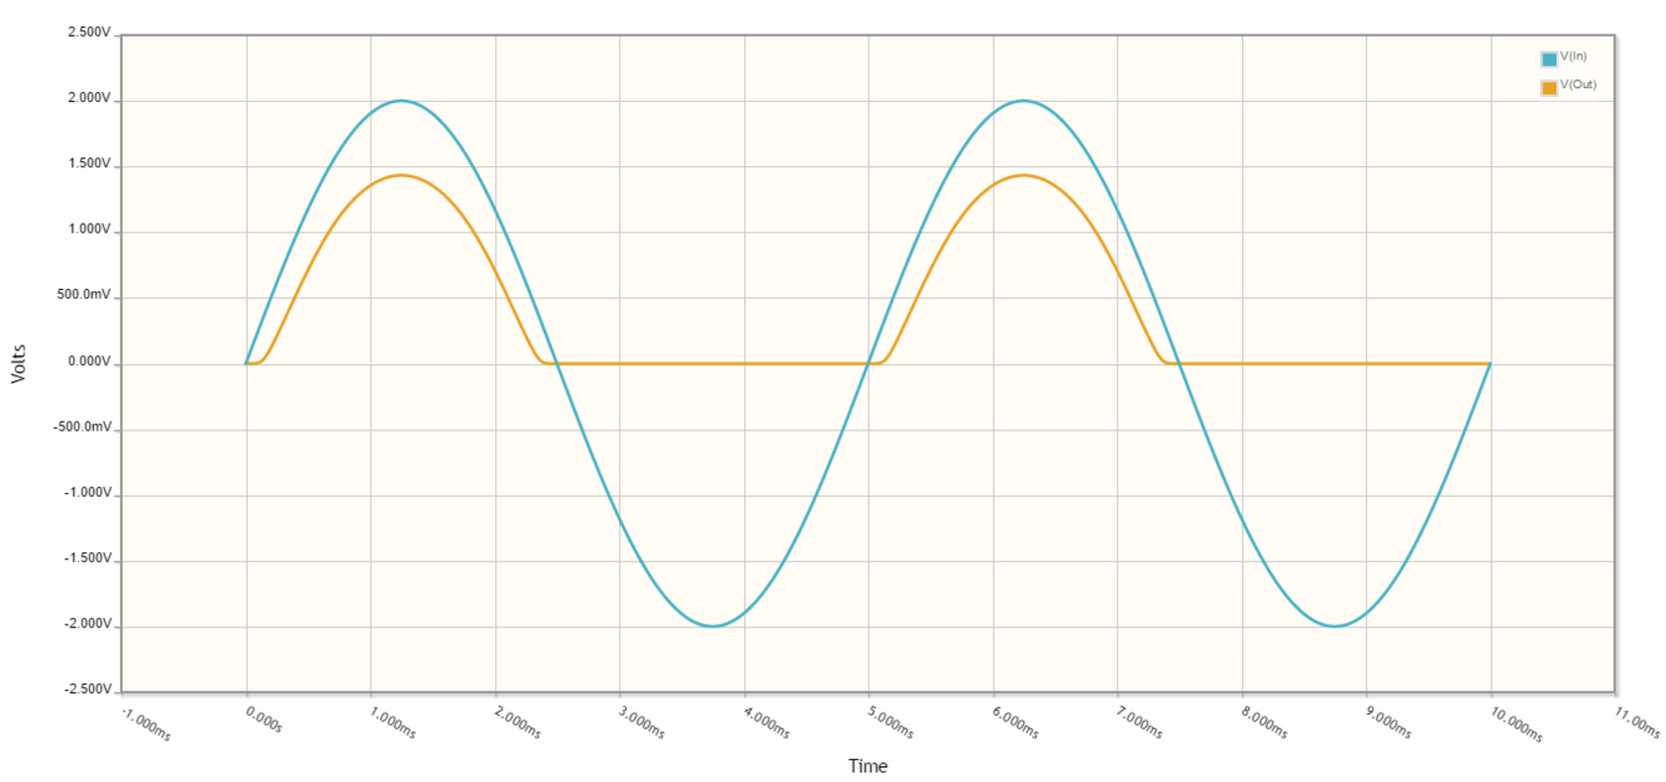

# Analysis (Part One)

* The input voltage can be seen to rise and fall in a regular sinusoidal fashion as expected of an a.c source. It oscillates between the peak voltage(s) of +/- 2V.
* The output voltage can be seen to oscillate in a sinusoidal manner on the positive side of the y-axis i.e when the voltage is a.c. However, as it intercepts the x-axis it can be seen to continue at a constant rate (0V) before once again oscillating above the x-axis.
* The LED can be seen to flicker when the source is set to a low frequency. This shows that the voltage is only oscillating every so often and when it isn’t oscillating the voltage is 0V.

# Uncertainty & Error (Part One)

* Errors when calibrating a zero reference for the oscilloscope
* Errors when choosing voltages and frequencies on the function generator
* Power lost through other energy conversions e.g heat
* Internal resistance of devices e.g the oscilloscope impacting readings

# Conclusions(Part One)

* Taking into account the uncertainties and errors above it can be concluded that when a diode is placed in series with an a.c power source it acts as a one-way filter. It only allows voltage to oscillate in one direction. This direction is determined by the direction of the bias of the diode. When voltage attempts to oscillate in the other direction the diode prevents it from doing so as a result of its depletion layer expanding, thus preventing the flow of electrons.

# Method (Part Two)

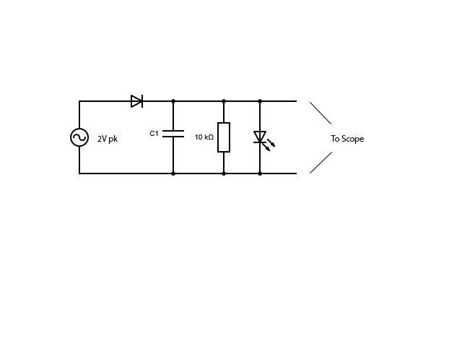 ***Fig 2.1***

1. The circuit was then changed and a capacitor (C1) was placed in parallel with the 10kΩ resistor and the LED as shown in *Fig 2.1*. C1 was set to 1µF and the frequency of the source voltage was set to 200Hz. Using an oscilloscope, the input and output voltages were recorded and graphed. The frequency of the source was then changed to 2000Hz and once again using an oscilloscope the input and output voltages were recorded and graphed. The graphs were then compared and the results recorded.

 ***Fig 2.2***

1. The circuit was arranged as shown in the above *Fig 2.2,* however this time the capacitance of C1 was changed to 10µF. The source voltage was initially set to a frequency of 200Hz. Using an oscilloscope, the input and output voltages were recorded and graphed. Similarly to section **a)** the frequency of the source was then changed to 2000Hz and using an oscilloscope the input and output voltages were recorded and graphed. The graphs were then compared and results recorded.

# Results (Part Two)

1. **1µF Capacitor @ 200Hz**

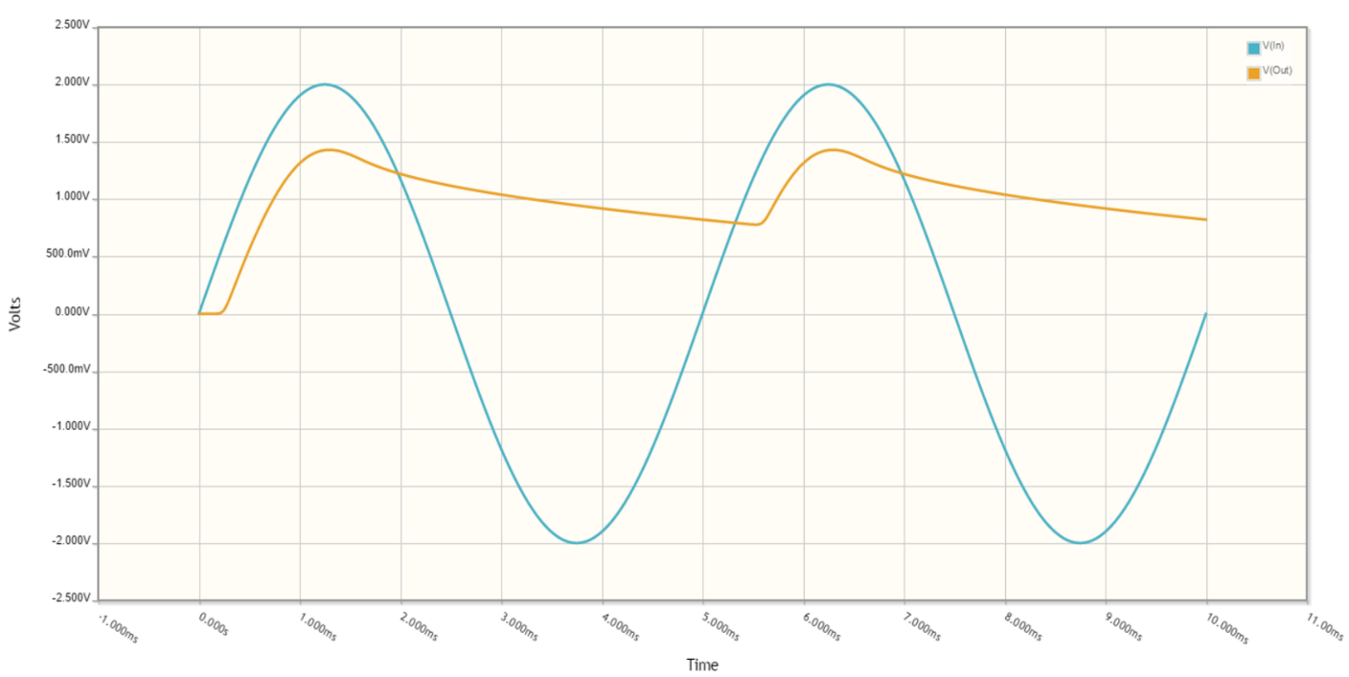

1. **1µF Capacitor @ 2000Hz**

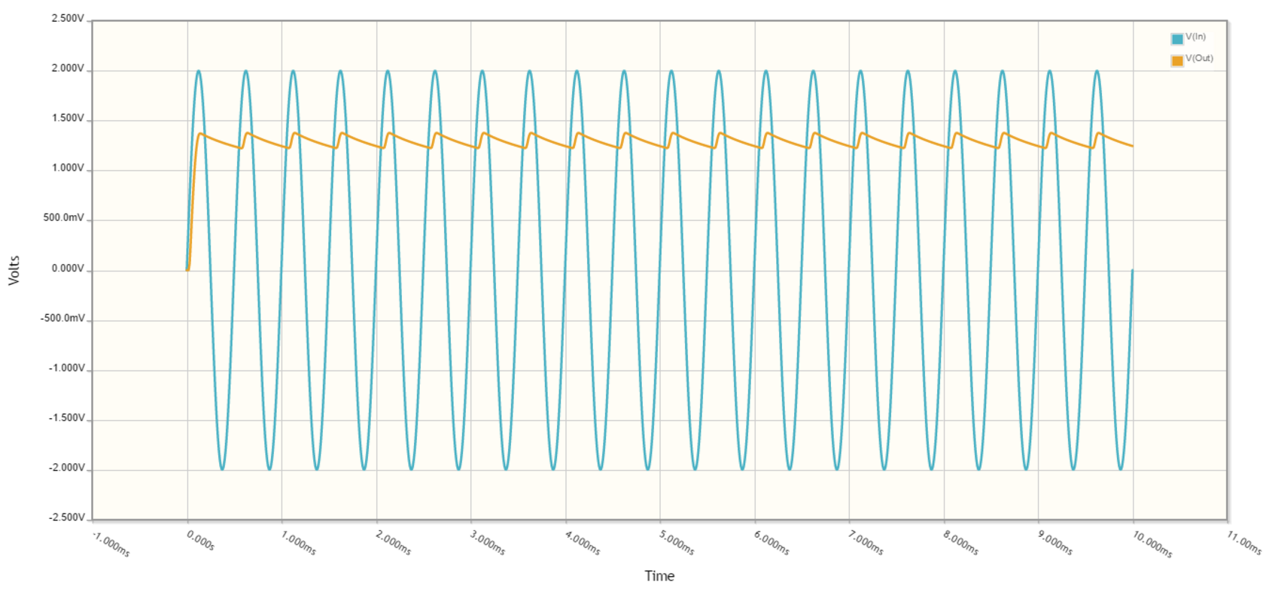

1. **10µF Capacitor @ 200Hz**

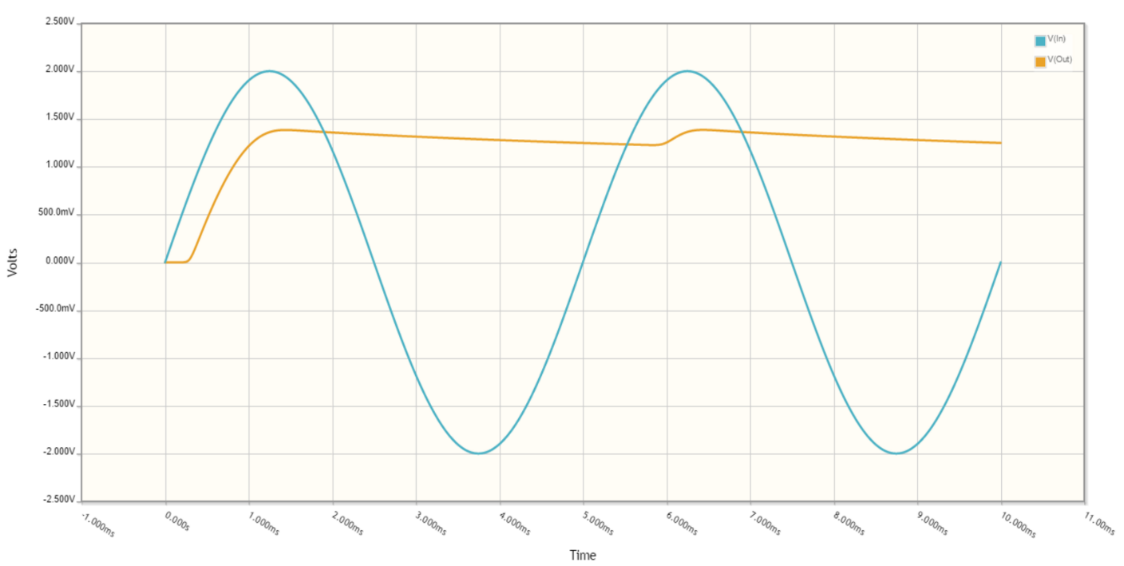

**b) 10µF Capacitor @ 2000Hz**

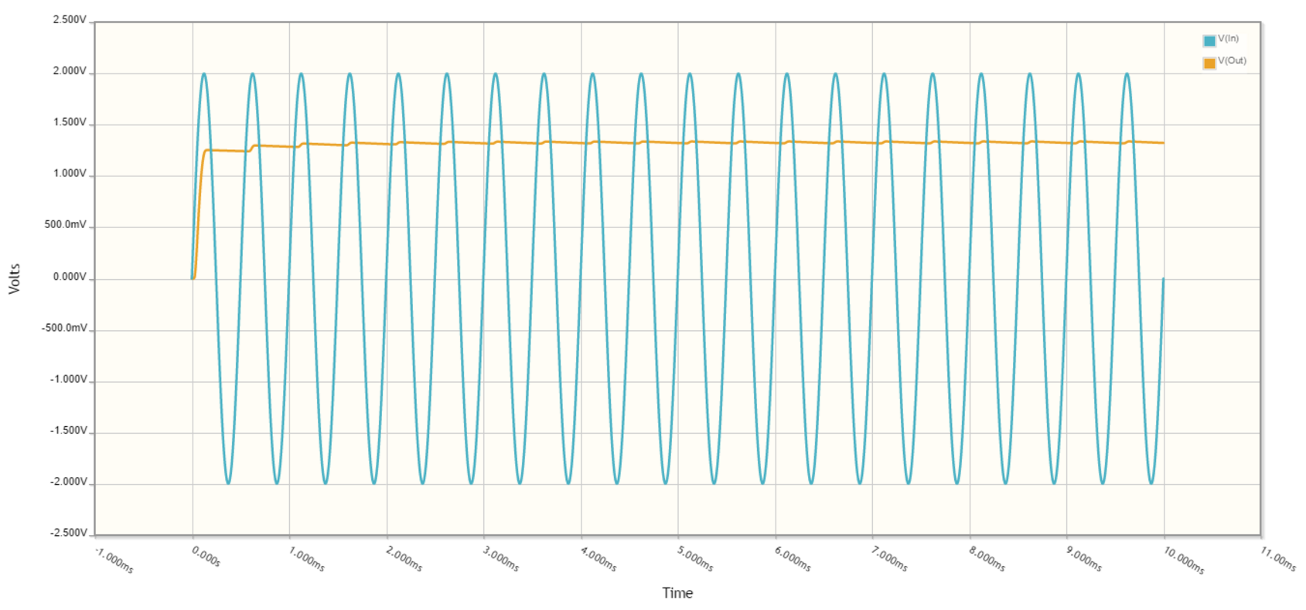

# Analysis (Part Two)

* **a)** When an a.c source is applied to the circuit as shown in *Fig 2.1* and the frequency is set to **200Hz** it has a significant effect on the output voltage. Instead of oscillating in a sinusoidal manner it now rises and falls whilst oscillating sharply in places. The output can still be considered to be primarily a.c.

However, when the frequency is changed to **2000Hz** the impact of the capacitor becomes even greater. The same effect as above is occurring albeit this time at a much more significant rate. This causes the output voltage to rise and fall by 0.2V twice every millisecond. The output voltage can be interpreted as being somewhat d.c.

* **b)** The impact when the capacitor is changed from 1µF to 10µF is substantial based on the above graphs. Due to the higher capacitance the range of the output voltage becomes significantly lower and tends towards +/- 0V. Even at a frequency of **200Hz** the output voltage can be seen to be almost d.c

When the frequency is changed to **2000Hz** the same range of output voltage is applied at a much higher rate. The voltage rises and falls by less than 0.1V twice every millisecond. The output voltage can be seen as almost perfectly d.c.

# Uncertainty and Error (Part Two)

* Errors when calibrating a zero reference for the oscilloscope
* Errors when choosing voltages and frequencies on the function generator
* Power lost through other energy conversions e.g heat
* Internal resistance of devices e.g the oscilloscope impacting readings

# Conclusions(Part Two)

* **Capacitors:** It can therefore be concluded that when an a.c source is applied to a circuit as shown in *Fig 2.1*the capacitor acts as an a.c to d.c converter or a filter against a.c current. As the voltage oscillates in the positive direction as seen in the graphs from *Part One*  the capacitor builds up charge on its parallel plates. Instead of the voltage remaining at 0V when the voltage changes direction, the capacitor now discharges the charge built up on the positive cycle in a somewhat d.c manner. Then, as the source once again changes direction it begins to charge up the plates on the capacitor and this is repeated over and over, allowing voltage to be oscillating throughout the circuit at all times.
* **Capacitance:** It can also be concluded that as capacitance is increased, so too is the impact of the capacitor on the output voltage. It can be seen from the graphs that as you increase the capacitance from 1µF to 10µF the output voltage tends from a.c to d.c. This is because as you increase the capacitance you increase the amount of charge that can be stored between its parallel plates, thus increasing the potential discharge of charge around the circuit.
* **Frequency:** It can further be concluded that increasing the frequency of an a.c source greatly increases the impact of the capacitor as a filter. By increasing the frequency, it causes the voltage to ‘oscillate’ at a much higher rate. Thus causing charge to be discharged at an extremely high rate. As the frequency tends towards infinity the output voltage also tends towards a constant value (d.c).

# Uses of A.C to D.C Converters

* **Everyday plugs** converting high voltage a.c from the mains to the necessary d.c voltage for common circuit use.